**Assignment – 1**

**Part-A**

**Camera Calibration:**

For Camera Calibration, we took the images of the chessboard by using the 0AK-D camera from a distance of 42.4 inches.

Calibrating the OAK-D camera using MATLAB:

% Auto-generated by cameraCalibrator app on 06-Oct-2022

%-------------------------------------------------------

% Define images to process

imageFileNames = {'/Users/iamns45/cv/image1.jpg',...

'/Users/iamns45/cv/image2.jpg',...

'/Users/iamns45/cv/image3.jpg',...

'/Users/iamns45/cv/image4.jpg',...

'/Users/iamns45/cv/image5.jpg',...

'/Users/iamns45/cv/image6.jpg',...

'/Users/iamns45/cv/image7.jpg',...

'/Users/iamns45/cv/image8.jpg',...

'/Users/iamns45/cv/image9.jpg',...

'/Users/iamns45/cv/image10.jpg',...

'/Users/iamns45/cv/image11.jpg',...

'/Users/iamns45/cv/image12.jpg',...

'/Users/iamns45/cv/image13.jpg',...

'/Users/iamns45/cv/image14.jpg',...

'/Users/iamns45/cv/image15.jpg',...

'/Users/iamns45/cv/image16.jpg',...

'/Users/iamns45/cv/image17.jpg',...

'/Users/iamns45/cv/image18.jpg',...

'/Users/iamns45/cv/image19.jpg',...

'/Users/iamns45/cv/image20.jpg',...

'/Users/iamns45/cv/image21.jpg',...

'/Users/iamns45/cv/image22.jpg',...

};

% Detect calibration pattern in images

detector = vision.calibration.monocular.CheckerboardDetector();

[imagePoints, imagesUsed] = detectPatternPoints(detector, imageFileNames);

imageFileNames = imageFileNames(imagesUsed);

% Read the first image to obtain image size

originalImage = imread(imageFileNames{1});

[mrows, ncols, ~] = size(originalImage);

% Generate world coordinates for the planar pattern keypoints

squareSize = 1.950000e+01; % in units of 'millimeters'

worldPoints = generateWorldPoints(detector, 'SquareSize', squareSize);

% Calibrate the camera

[cameraParams, imagesUsed, estimationErrors] = estimateCameraParameters(imagePoints, worldPoints, ...

'EstimateSkew', false, 'EstimateTangentialDistortion', false, ...

'NumRadialDistortionCoefficients', 2, 'WorldUnits', 'millimeters', ...

'InitialIntrinsicMatrix', [], 'InitialRadialDistortion', [], ...

'ImageSize', [mrows, ncols]);

% View reprojection errors

h1=figure; showReprojectionErrors(cameraParams);

% Visualize pattern locations

h2=figure; showExtrinsics(cameraParams, 'CameraCentric');

% Display parameter estimation errors

displayErrors(estimationErrors, cameraParams);

% For example, you can use the calibration data to remove effects of lens distortion.

undistortedImage = undistortImage(originalImage, cameraParams);

% See additional examples of how to use the calibration data. At the prompt type:

% showdemo('MeasuringPlanarObjectsExample')

% showdemo('StructureFromMotionExample')

**OUTPUT:**

**PART B**

MATLAB Script to find the real-world dimension

**Code:**

I=imread("/Users/iamns45/cv/image6.jpg ")

imshow(I)

[x,y]=ginput(2)

z_dist=939.8

fx=1329.3020

fy=1330.4565

x1=z*(x(1)/fx)

x2=z*(x(2)/fx)

y1=z*(y(1)/fy)

y2=z*(y(2)/fy)

dist=sqrt((y2-y1)^2+(x2-x1)^2)

fprintf("The Estimated distance Between 2 points",dist)

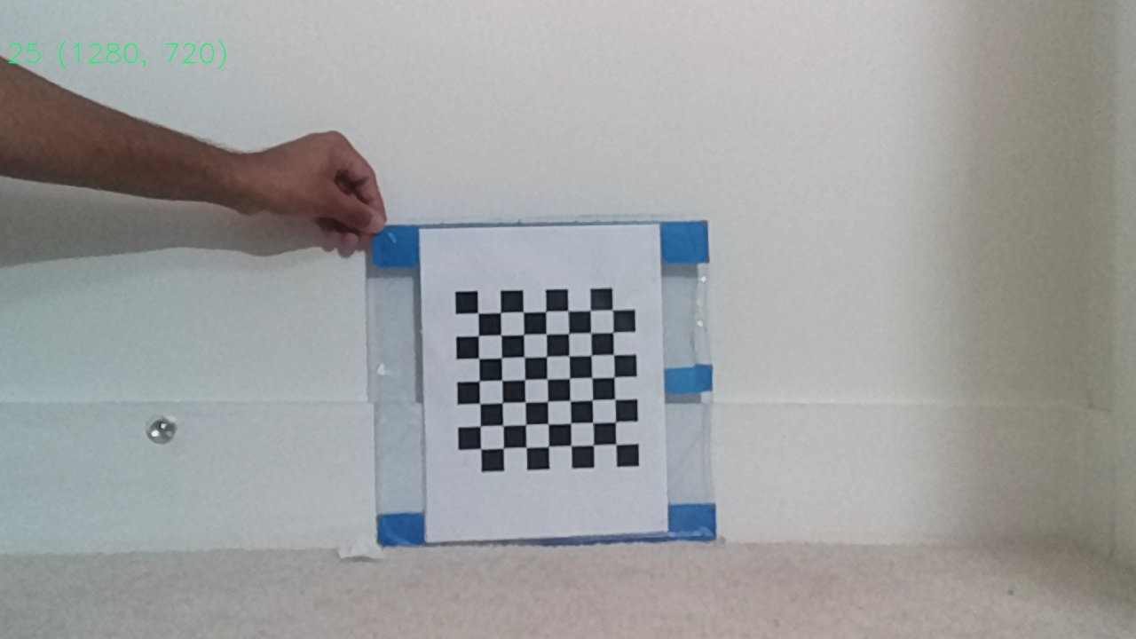

**Output:**

**The Estimated distance between 2 points is 21.2mm**

**The original distance is 20.5mm**

**PART-C**

It is feasible to show to show an RGB stream from the mono camera and a depth map stream from the stereo camera simultaneously.

Fig. Combination of RGB and depth

Fig. Depth map

Fig. RGB

Maximum 32fps

1280 720 resolution(720p)

**Video Link:**

<https://drive.google.com/file/d/1AJ_OfxIJZOrexerqGdtAFZs5G8MWNX4B/view?usp=sharing>

**GitHub link:**

**https://github.com/Iamns45/Computer-Vision.git**